**BVM Engineering College**

**Computer Department**

**4CP50: Python Programming**

**Assignment-2**

**1.Python Program to Display the multiplication Table of a Number.**

**Code:**

n=int(input('Enter number :'))

for i in range(1,11):

print(n,' ',i,' ',n*i)

**Output: 13.py**

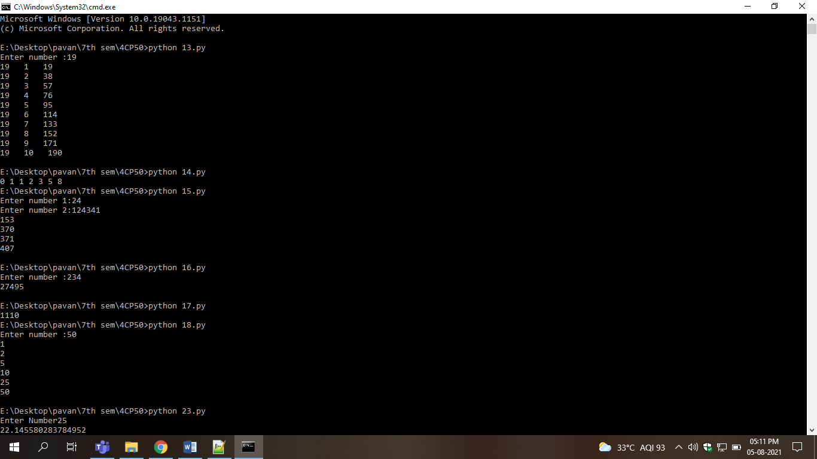

**2.Python Program to Print the Fibonacci sequence**

**Code:**

def printFibonacciNumbers(n):

f1 = 0

f2 = 1

if (n < 1):

return

print(f1, end=" ")

for x in range(1, n):

print(f2, end=" ")

next = f1 + f2

f1 = f2

f2 = next

printFibonacciNumbers(7)

**Output: 14.py**



**3.Python Program to Print all Armstrong Number in an Interval**

**Code:**

n1=int(input('Enter number 1:'))

n2=int(input('Enter number 2:'))

for i in range(n1,n2+1):

sum=0

s=list(map(int,list(str(i))))

for j in s:

sum=sum+j**3

if sum==i:

print(i)

sum=0

**Output:15.py**



**4.Python Program to Find the Sum of Natural Numbers**

**Code:**

n=int(input('Enter number :'))

sum=0

for i in range(1,n+1):

sum+=i

print(sum)

**Output:16.py**



**5.Python Program to Convert Decimal to Binary**

**Code:**

def DecimalToBinary(num):

if num >= 1:

DecimalToBinary(num // 2)

print(num % 2,end='')

DecimalToBinary(14)

**Output:17.pys**



**6.Python Program to Find Factors of Number**

**Code:**

n=int(input('Enter number :'))

for i in range(1,n+1):

if n%i==0:

print(i)

**Output:18.py**



**7.Write a program to compute 1/2+2/3+3/4+...+n/n+1 with a given n input by console (n>0).**

**Code:**

n=int(input("Enter Number"))

sum=0

for i in range(n+1):

sum=sum+(i/(i+1))

print(sum)

**Output:23.py**



**8.Python Program to Display Different Patterns.**

**Code:**

print('')

print('Pattern 1')

for i in range(1,6):

for j in range(i):

print('*',end=' ')

print('')

for i in range(6,0,-1):

for j in range(i):

print('*',end=' ')

print('')

print('')

print('Pattern 2')

t=6

for i in range(1,7):

for j in range(i):

print(i-j,end=' ')

print('')

print('')

print('Pattern 3')

t=1

for i in range(1,5):

for j in range(5-i):

print(' ',end=' ')

for j in range(i):

print(chr(64+t),end=' ')

t+=1

print('')

print('')

print('Pattern 4')

for i in range(1,5):

for j in range(i):

print(chr(65+j),end=' ')

print(' ')

print('')

print('Pattern 5')

t=1

for i in range(1,6):

for j in range(6-i):

print(' ',end=' ')

for j in range(i):

print(' *',end=' ')

print(' ')

for i in range(1,5):

for j in range(i+1):

print(' ',end=' ')

for j in range(5-i):

print(' *',end=' ')

print('')

print('')

print('Pattern 6')

for i in range(6):

for j in range(5,i,-1):

print(i+1,end=' ')

print(' ')

**Output:**

